Neural Network Summary
Hyperparameters
- Configuration: input (10, 8, 5) (8, 5) output
- Regularization: None, L1 (penalties @ 0.0001 and 0.001), L2 (penalties @ 0.0001 and 0.001)
Procedure
Because our previous testing set did not include any samples from category 0, it was still unclear whether the model successfully learned to differentiate the category 0 images. One preannealing image was manually moved from the training set (90%) to the testing set (10%). Grid search was done using the hyperparameters listed above, generating a total of 30 models. Each model was trained with 10-fold cross validation and for 700 epochs. Training and cross-validation accuracies were recorded at intervals of 25 epochs to generate a curve demonstrating their relationship. For each model, the epoch interval at which the cross-validation curve plateaued or peaked was recorded. The cross-validation scores of the models at these specific epochs were analyzed. Other data entries were discarded.
The highest cross-validation score (0.808 +/- 0.161) was reported from the model with the following hyperparameters: architecture @ (12,5,8,4), regularization @ L1 with penalty 0.001, and epoch @ 525. This model generated predictions for the testing set with 87.5% accuracy (confusion matrix = [[1,0,0,0], [0,1,1,0], [0,0,3,0], [0,0,0,2]]). The epoch curve (See Fig. 1) for the model is displayed below to justify epoch selection.
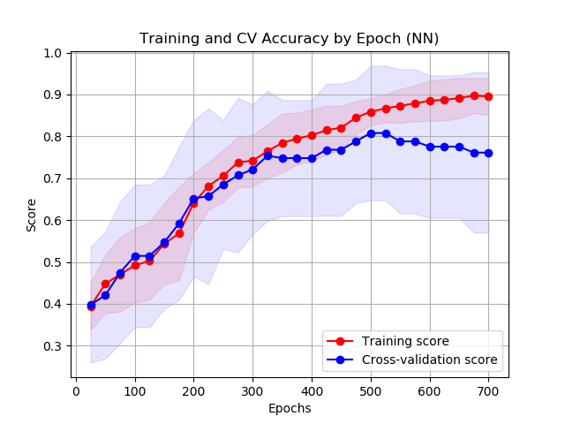
Fig 1: Architecture @ (12,5,8,4), Regularization @ L1 with Penalty 0.001, and Epoch @ 525

